
State of Arizona
Department of Liquor Licenses and Control
Liquor Law Training

December 16, 2008

Dear Arizona liquor industry stakeholders,

Thank you for the countless hours you have collectively invested assisting the Department of Liquor Licenses and Control (DLLC) as we improve Title 4 training standards. During the past few months, you have provided us with liquor industry perspectives relevant to; 1) the establishment of reasonable timeframes to implement new training standards; 2) innovative approaches to on-line training and testing methods; and 3) economically feasible solutions for statewide improvements in Title 4 training, and ultimately compliance, for everyone who sells and/or serves liquor.

Many of your recommendations are being written into the Newly Proposed Draft Rules. A final version of those Rules, which will include the new training standards, is anticipated to be submitted to the Governor’s Regulatory Review Counsel (GRRC) in time to be implemented before July 30, 2009.

Licensees and industry stakeholders will receive notice of the newly adopted Title 4 Rules and timelines for implementation, compliance, and law enforcement through DLLC’s website at www.azliquor.gov, statewide media outlets, industry newsletters and magazines, and at the time of liquor license issuance or renewal.

DLLC continues to benefit from, and enjoys working with each and every one of you in this collective commitment to improving health and safety in Arizona.

Sincerely,
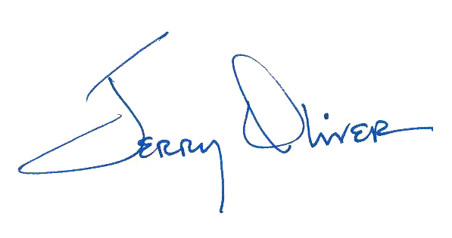
Jerry A. Oliver, Sr.
Director

Newly Proposed Rulemaking – FINAL DRAFT

Translation Table

Rulemaking Calendar of Events

Email A Question

